Kalyani Government Engineering College

#### (Affiliated to Maulana Abul Kalam Azad University of Technology, West Bengal)

Kalyani - 741235, Nadia, WB



Project Report on

# IOT BASED AUTO IRRIGATION SYSTEM

### (A dissertation submitted in partial fulfillment of the requirements of Master of Technology in Computer Science and Engineering of Maulana Abul Kalam Azad University of Technology, West Bengal)

Submitted by SOUVIK MONDAL

University Roll Number: 10211220015

Under the guidance of Mr.Arindrajit Pal

Assistant Professor

Department of Computer Science and Engineering 2022



**Certificate of Approval**

This is to certify that the project report on **IoT based Auto Irrigation System** is a record of bonafide work, carried out by SOUVIK MONDAL under my guidance and supervision.

In my opinion, the report in its present form is in conformity as specified by Kalyani Government Engineering College and as per regulations of the Maulana Abul Kalam Azad University of Technology. To the best of my knowledge, the results presented here are original in nature and worthy of incorporation in project report for the M.Tech. program in Computer Science and Engineering.

Signature of Supervisor: Name and affiliation:

Signature of Head, Dept. of CSE

**ACKNOWLEDGEMENT**

I would like to take this opportunity to express sense of gratitude and indebtedness to Mr. Arindrajit Pal, Assistant Professor of Department of Computer Science and Engineering College for his constant support and encouragement at the various stages of this thesis work.

I express my deep sense of gratitude to my respected Professor Dr. M. K. Pakhira, Head of Department of Computer Science and Engineering, for kind cooperation. I also owe my sincere thanks to Dr. Swapan Kumar Mondal, Kalyani govt. Engineering College, Department of Computer Science and Engineering.

I must express my gratitude to my parents and family members for being with me at every moment and providing continuous moral boosting and affection during thesis work. I must add that it has been a great experience studying at Kalyani Govt. Engineering College and I will always cherish the haloed memory of my alma mater. Lastly, I thank the Almighty for being always there for me.



Signature

SOUVIK MONDAL Roll No: 10211220015

Declaration by the student

I SOUVIK MONDAL, a student of M.Tech, CSE 2nd year have submitted this report in partial fulfillment of the requirements of Master of Technology in Computer Science and Engineering of Maulana Abul Kalam Azad University of Technology, West Bengal.

I further declare that I have not committed plagiarism in any form or violated copyright while prepared this report. I have attached the plagiarism report at the end.

Name of the student: SOUVIK MONDAL University Roll Number: 10211220015

Full signature: Date: 01.06.2022

# ABSTRACT

India is mainly an agricultural country. To serve the humanity nowadays technology is playing a wonderful role and a man’s basic and primary need is food indeed. Agriculture is the most important occupation for the most of the Indian families. Proper irrigation by water pump cannot be maintained due to frequent power outages, unavailability of grid lines in remote areas and scarcity/cost of fuel to run pumps. To make the sustainable irrigation system and field monitoring system for getting better crops growth as well as best production, this IOT based Automatic irrigation system is proposed. In this system IOT is used to control and monitor the irrigation system.

Irrigation is one method to supply water but in some cases there will be lot of water wastage. So, in this regard to save water and time we have proposed project titled automatic irrigation system using IoT. In this proposed system we are using various sensors like temperature, humidity, soil moisture sensors which senses the various parameters of the soil and based on soil moisture value land gets automatically irrigated by ON/OFF of the motor.

This system will be more useful in areas where water is in scarce and more efficient than the conventional approach.

# CONTENT

CHAPTER 1: INTRODUCTION 1

* 1. Motivation 2
  2. Background 3
  3. Summary of present work 4

CHAPTER 2 : METHODOLOGY 5

* 1. Software Use 5
     1. Embedded C 5
     2. Arduino IDE 5
     3. HTML 6
     4. CSS 6
     5. JavaScript 6
  2. Hardware Use 7
     1. NodeMcu ESP8266 7
     2. Soil Moisture Sencor 7
     3. DHT11 Temperature and Humidity sensor 8
     4. OLED DISPLAY 8
     5. Other hardware parts 9
  3. Web server handling 9
  4. Database Connection 9
  5. Results 10

CHAPTER 3 : CONCLUSIONS 10

CHAPTER 4 : FUTURE SCOPE OF WORK 11

REFERENCES 12

# CHAPTER 1 INTRODUCTION

Most of the farmers use large portions of farming land and it becomes very difficult to reach and track each corner of large lands. Sometime there is a possibility of uneven water sprinkles. This result in the bad quality crops which further leads to financial losses. In this scenario the Smart Irrigation System using Latest IoT technology is helpful and leads to ease of farming.

The Smart irrigation System has wide scope to automate the complete irrigation system. Here we are building a IoT based Irrigation System using ESP8266 NodeMCU Module and Soil Moisture and DHT11 Sensor. It will not only automatically irrigate the water based on the moisture level in the soil but also send the Data to My Server to keep track of the land condition. The System will consist a water pump which will be used to sprinkle water on the land depending upon the Land and environmental condition such as Moisture, Temperature and Humidity.

Before starting, it is important to note that the different crops require different Soil Moisture, Temperature and Humidity Condition. So, in this matter we are using such a crop which will require a soil moisture of about 50-55%. So, when the soil loses its moisture to less than 50% then Motor pump will turn on automatically to sprinkle the water and it will continue to sprinkle the water until the moisture goes up to 55% and after that the pump will be turned off. The sensor data will be sent to My Server in defined interval of time so that it can be monitored from anywhere in the world.

##### Motivitation

Fresh Water is used in our daily life, and use it to irrigate our plants. However there is shortage of fresh water.Water scarcity, which already affects one in three people on Earth, is set to increase in magnitude and scope as the global population grows, increasing affluence drives up demand, and the climate changes.

Just 1 percent of our freshwater is easily accessible, with much of it trapped in glaciers and snowfields.

Therefore, optimal usage of water must be exercised in all fields of usage. When it comes to water usage, agriculture is by far the largest consumer of the Earths available freshwater: 70 percent of blue water withdrawals from water

coursesand groundwater are for agricultural usage, three times more than 50 years ago. By 2050, the global water demand of agriculture is estimated to increase by a further 19 percent due to irrigation needs. For example, Agriculture is a significant water user in Asia, accounting for around 33 percent of total water use. This share varies markedly, however, and can reach up to 80 percent in parts of southern Europe, where irrigation of crops accounts for virtually all agricultural water use.

Furthermore, using too much wateron irrigation can harm the crops and the soil, soil saturation, leading to lower quality of crops on the short and long terms. Therefore, smart irrigation using IoT is needed to cut short the amounts of water wasted, to control the right amounts of water for irrigating, and to collect data for further studies on soil and vegetation to produce better crops.

##### BACKGROUND

Although IoT has not widely spread in the irrigation field yet and most researches es- tablished over irrigation systems are theoretical, there are some researches that have actualized implementations of smart irrigation. These next researches are some of those actualized implementations that are close to what this thesis objective implies.

In this approach, an automated irrigation system is developed to optimize water utilization for agricultural applications. The system utilizes Wi-Fi (Wireless Fidelity) modules to establish a connection between an NodeMcu and a website for viewing the sensor data and for controlling the water pumps using a relay module. The thresholds for the soil moisture is set hard-coded in the micro-controller to establish the levels of irrigation needed for a certain soil type. Although the user decides when to irrigate, the micro-controller sends a notification based on an algorithm withtemperature, soil moisture percentage, and humidity levels as inputs to decide when itis needed for irrigation. The website views the data collected from the micro-controller through the Wi-Fi connection. It also relays the commands generated from the website to control the irrigation process through the NodeMcu. The water irrigation will turn on manually with the user intervention at any time desired.

##### SUMMERY OF PRESENT WORK

Once the Motor pump has started- following automated condition will work

* + 1. User can set the desired Threshold value from the web page as per he need to start the Pump Motor.
    2. The motor pump will automatically get switched OFF once the soil moisture sensor has reached the required threshold value.
    3. Also in case, when power supply gets cut-off and motor gets switched off. It will restart again automatically when there will be availability power supply, user will have not to worry about restarting the motor pump manually.
    4. Also, data of various sensor like- moisture sensor, temperature sensor, humidity sensor will be displayed on website.

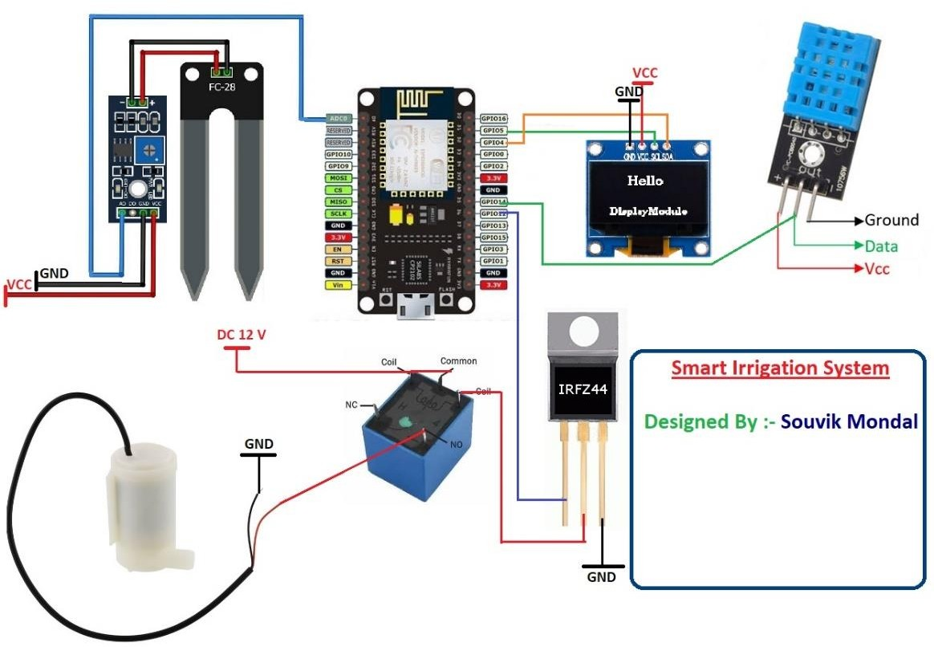

Figure 1:- Circuit Diagram

# CHAPTER 2 METHODOLOGY

In this era, IoT is connected to all fields on industrial level, therefore there are so many examples of already implemented approaches for connecting IoT to agricultural usage making it easier to integrate IoT with farming. This paper suggests a prototype whichseeks to solve many of the issues faced with earlier approaches such as range, powerconsumption, financial cost, and precision of irrigation.

## SOFTWARE USED

##### Embedded C

Embedded C is a set of language extensions for the C programming language by the C Standards Committee to address commonality issues that exist between C extensions for different embedded systems. Historically, embedded C programming requires nonstandard extensions to the C language in order to support exotic features such as fixed-pointarithmetic, multiple distinct memory banks, and basic I/O operations. In 2008, the C Standards Committee extended the C language to address these issues by providing a common standard for all implementations to adhere to. It includes a number of features not available in normal C, such as _xed-point arithmetic, named address spaces and basic I/O hardware addressing. Embedded C uses most of the syntax and semantics of standard C, e.g., main () function, variable definition, data- type declaration, conditional statements (if, switch case), loops (while, for), functions, arrays and strings,structures and union, bit operations, macros, etc.

##### Arduino IDE

The open-source Arduino Software (IDE) makes it easy to write code and upload it to theboard. It runs on Windows, Mac OS X, and Linux. The environment is written in Java and based on Processing and other open-source software. This software can be used withany Arduino board. The language written in the Arduino IDE is C++. To download the ESP32 boards on the Arduino IDE, the ESP32 boards git-hub link must be added tothe preferences in settings. There are two setups for the Arduino IDE for this project.The first setup is for the Arduino Nano, where the board must be Arduino Nano, theprocessor is ATmega328p (oldbooter), and the port is of the device. The other setup isfor the ESP32 board where the board must be FireBeetle-Esp32, the ash frequency is 80MHz, and the upload speed is 921600.

##### HTML

Hypertext Markup Language (HTML) is the standard markup language for creating web pages and web applications. With Cascading Style Sheets (CSS) and JavaScript, it formsa triad of cornerstone technologies for the World Wide Web.

##### CSS

Cascading Style Sheets is a style sheet language used for describing the presentation of a document written in a markup language like HTML. CSS is a cornerstone technology of the World Wide Web, alongside HTML and JavaScript.

##### JavaScript

JavaScript, often abbreviated as JS, is a high-level, interpreted programming language that conforms to the ECMAScript specification. It is a programming language that is characterized as dynamic, weakly typed, prototype-based and multi-paradigm.

* 1. **HARDWATRE USED**

##### NodeMCU ESP8266

NodeMCU is an open-source Lua based firmware and development board specially targeted for IoT based Applications. It includes firmware that runs on the ESP8266 Wi-Fi SoC from Espressif Systems, and hardware which is based on the ESP-12 module.

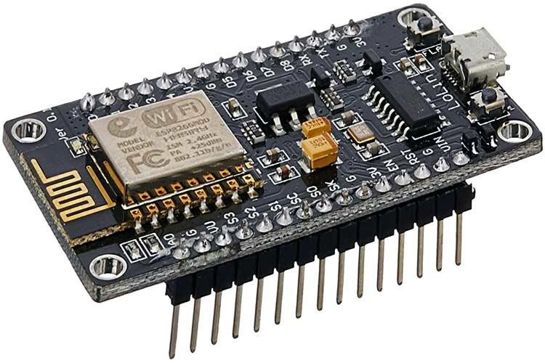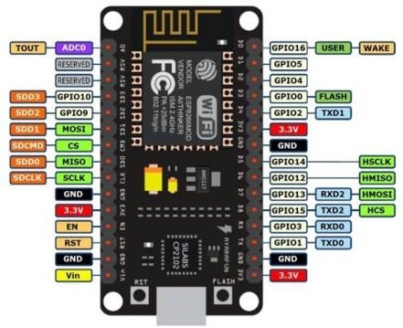

Figure 2: NodeMcu

##### Soil Moisture sensor

Soil moisture sensor is used for measuring the volumetric water content of the soil and loss of moisture which occurs due to evaporation and plant uptake. For survival of all plants, water is the most important factor. This soil moisture sensor

determines the amount of water required for irrigation of plants. This module consists of LM393 comparator with a potentiometer included in it for adjusting the soil wet/dry detection sensitivity according to the requirements of plants.

The sensor sends an analog signal which is connected to the analog to digital converter pins in the NodeMcu to get the soil moisture percentage. The analog signal varies from 0 to 1024 steps of analog conversion where 0 is the most water and 1024 is the least water. However, some of the product sensor can be defective and can only detect up to acertain level (e.g. up to 200). Therefore, a test must be done where the sensor is directly put in water and measuring the output where it is considered the highest moisture soil canreach. After mapping the values to range from 0 to 100, the percentage of soil moisture can be measured where 0 is the lowest and 100 is the highest.

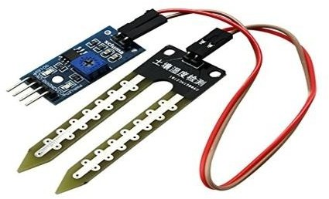

Figure3 : Soil moisture sensor

##### DHT11 Temperature and Humidity sensor

This DHT11 Temperature and Humidity Sensor (Figure 3.5) features a calibrated digital signal output with the temperature and humidity sensor capability. It is integrated witha high-performance 8-bit micro-controller. Its technology ensures the high reliability and excellent long-term stability. This sensor includes a resistive element and a sensor forwet NTC temperature measuring devices. It has excellent quality, fast response, anti-interference ability and high performance.

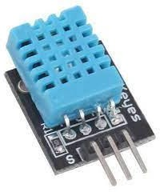The sensor is fast, which can calculate the temperature and humidity in 1 second. The sensor has 3 pins: 1 power, 1 ground, and 1 data. To get the data from the data pin, the data pin must be connected to a digital pin. Moreover, the library for DHT11 mustbe installed and used to extract the data. If the values are accessed before a second ofasking for it, the values produced are invalid and may produce wrong numbers. However, leaving a second of delay can solve the issue.

Figure 4: DHT11 temperature and Humidity sensor

##### OLED Display

OLEDs enable emissive displays - which means that each pixel is controlled individually and emits its own light (unlike LCDs in which the light comes from a backlighting unit). OLED displays feature great image quality - bright colors, fast motion and most importantly - very high contrast. Most notably, “real” blacks (that cannot be achieved in LCDs due to the backlighting). The simple OLED design also means that it is relatively easy to produce flexible and transparent displays.

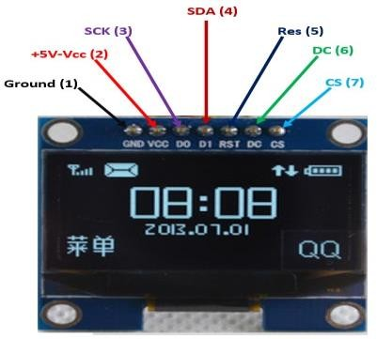

Figure5 : OLED Display

##### Other hardware parts

1. Bread boards
2. 10k resistors
3. Jumper wires
4. 9v batteries
5. Female-female wires and female-male wires

## Web server handling

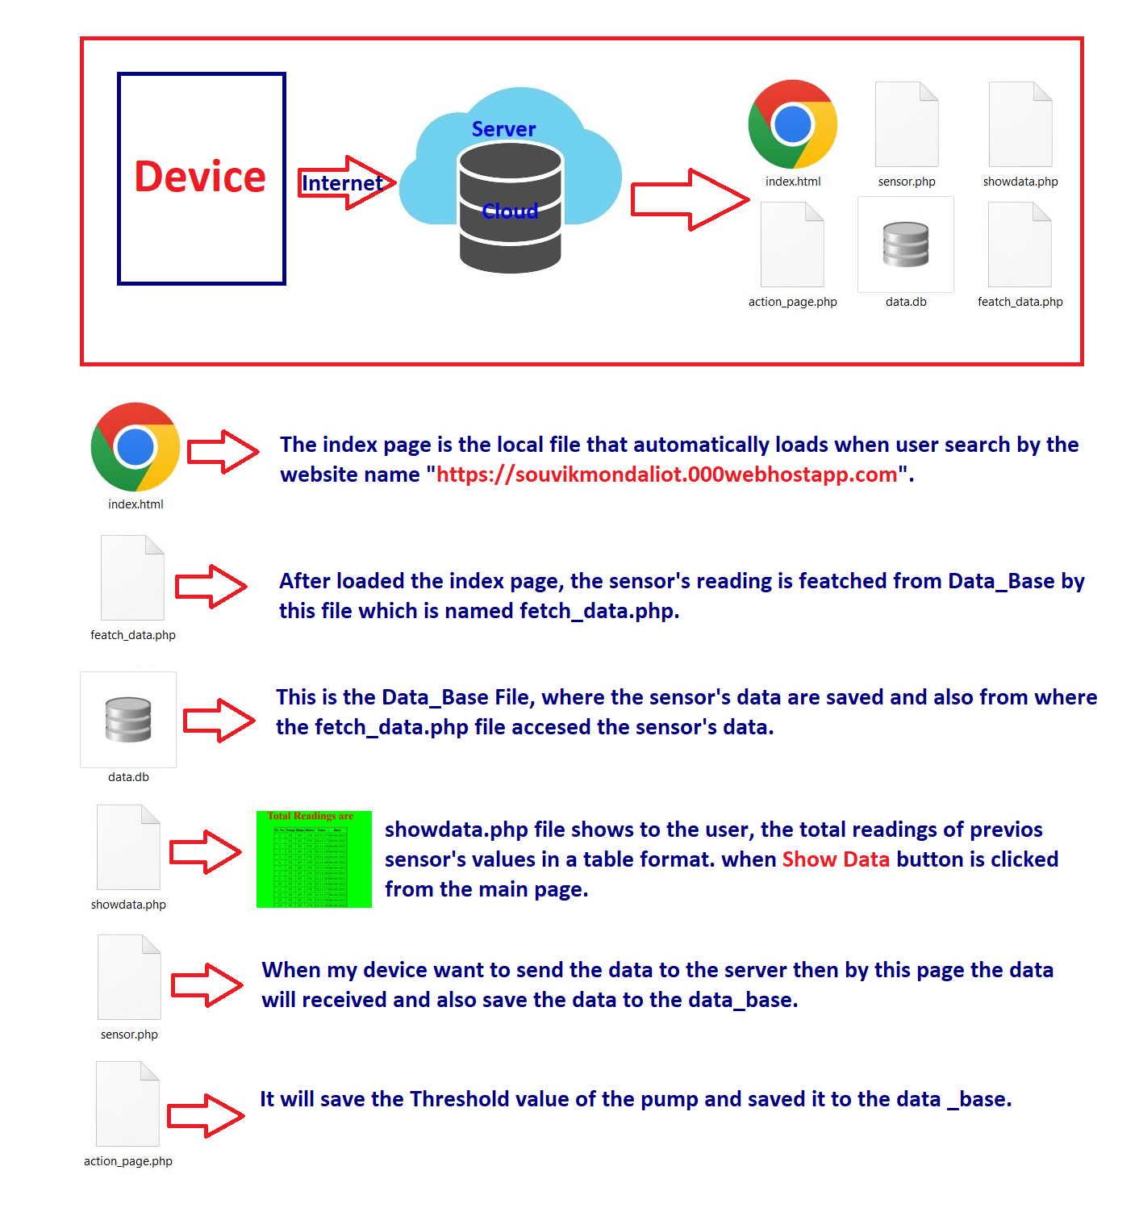

## Results

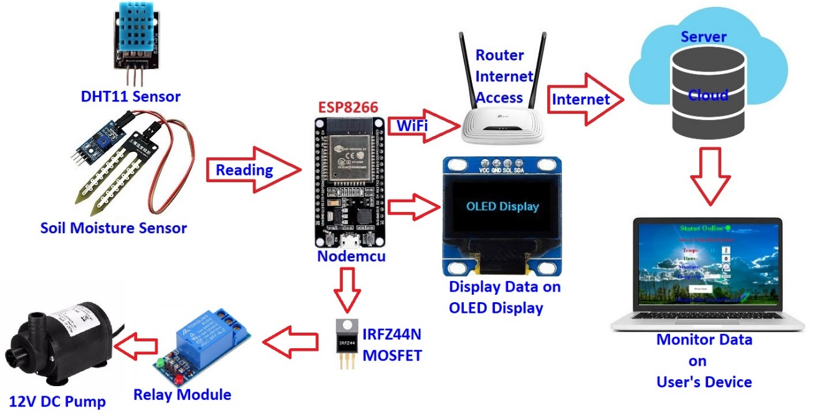

# CHAPTER 3

**Conclusion**

The main achievement of our thesis is to build a system of real time monitoring and stored data monitoring of the soil condition during irrigation. As ours have an agriculturally based economy we haveto be fully focused on maximum productivity. So, water wastage and soil monitoring during irrigation hasto be done at a satisfactory rate so that maximum production can be ensured. The main objective of ourthesis is to design a fully automated drip irrigation system and real time soil monitoring, stored data monitoring using IOT. The system provides an efficient monitoring of moisture, humidity and temperature content of soil. The data collected by the system can be used for further analysis purpose.

# CHAPTER 4

**Future Scope of Work**

As per future perspective, this system can be the more intelligent system which predicts user actions, nutrient level of the plants, time to harvest, etc. With using Machine Learning algorithms more advancements can be done in the future which will help farmer a lot and water consumption can also be reduced in agriculture.

# REFERENCES

1. Goap, Amarendra, Sharma, Deepak, Shukla, A. K., Rama Krishna, C., “An IoT based smart irrigation management system using Machine learning and open source technologies”, Computers and Electronics in Agriculture, vol.155, pp. 41-49, September, 2018
2. Nawandar, Neha K., Satpute, Vishal R., “IoT based low cost and intelligent module for smart irrigation system”, Computers and Electronics in Agriculture, vol.162, pp. 979-990, May, 2019.
3. Karimi, NavabArabhosseini, Akbar Karimi, MortazaKianmehr, Mohammad Hossein., “Web-based monitoring system using Wireless Sensor Networks for traditional vineyards and grape drying buildings”, Computers and Electronics in Agriculture, vol.144, pp. 269-283, September, 2016
4. Moreno-Moreno, Carlos D. Brox-Jiménez, María Gersnoviez-Milla, Andrés A. Márquez-Moyano, Mariano Ortiz-López, Manuel A. Quiles-Latorre, Francisco J., “Wireless Sensor Network for Sustainable Agriculture”, Proceedings, vol.2, pp. 1302, 2018
5. Difallah, WafaBenahmed, KhelifaDraoui, BelkacemBounaama, Fateh., “Implementing wireless sensor networks for smart irrigation”, Taiwan Water Conservancy, vol.65, pp. 44-54, 2018
6. A Di Nisio, T. Di Noia, C. GuamieriCalo Carducci, M Spardavecchia., “Design of a Low Cost Multipurpose Wireless Sensor Network”.